See bst has 2 condition. 1st is left small and right is bigger.2nd is that tree should be complete binary tree.

But for min heap:

See complete binary tree already fulfilled but 2nd condition we need to fulfill.

See we also know that bst in order is the sorted data.so when we make a binary tree using this sorted data will give us the min heap.

See we need to fill this inorder into the preorder form for min heap(root ,left , right is for preorder)

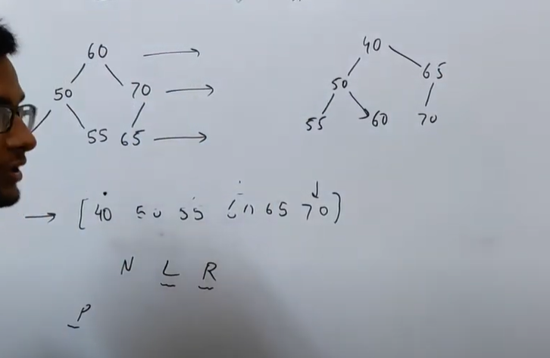

See using that data to fill preorder give us the tree.

We need to do this.

Code:

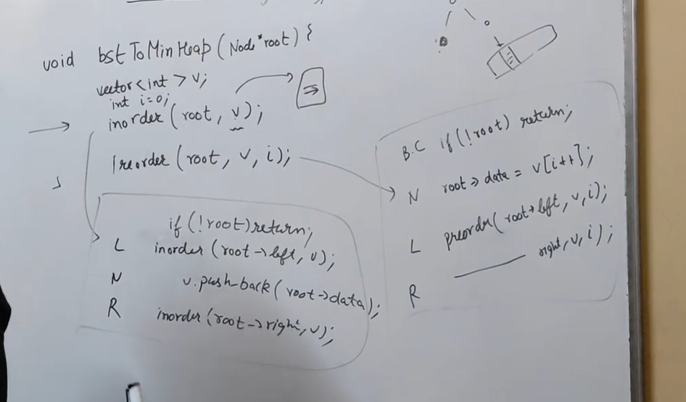

This the code.